What on Earth
Tess Bilhartz

Curated by Mo Kong and Wangui Maina

October 14- November 22, 2020

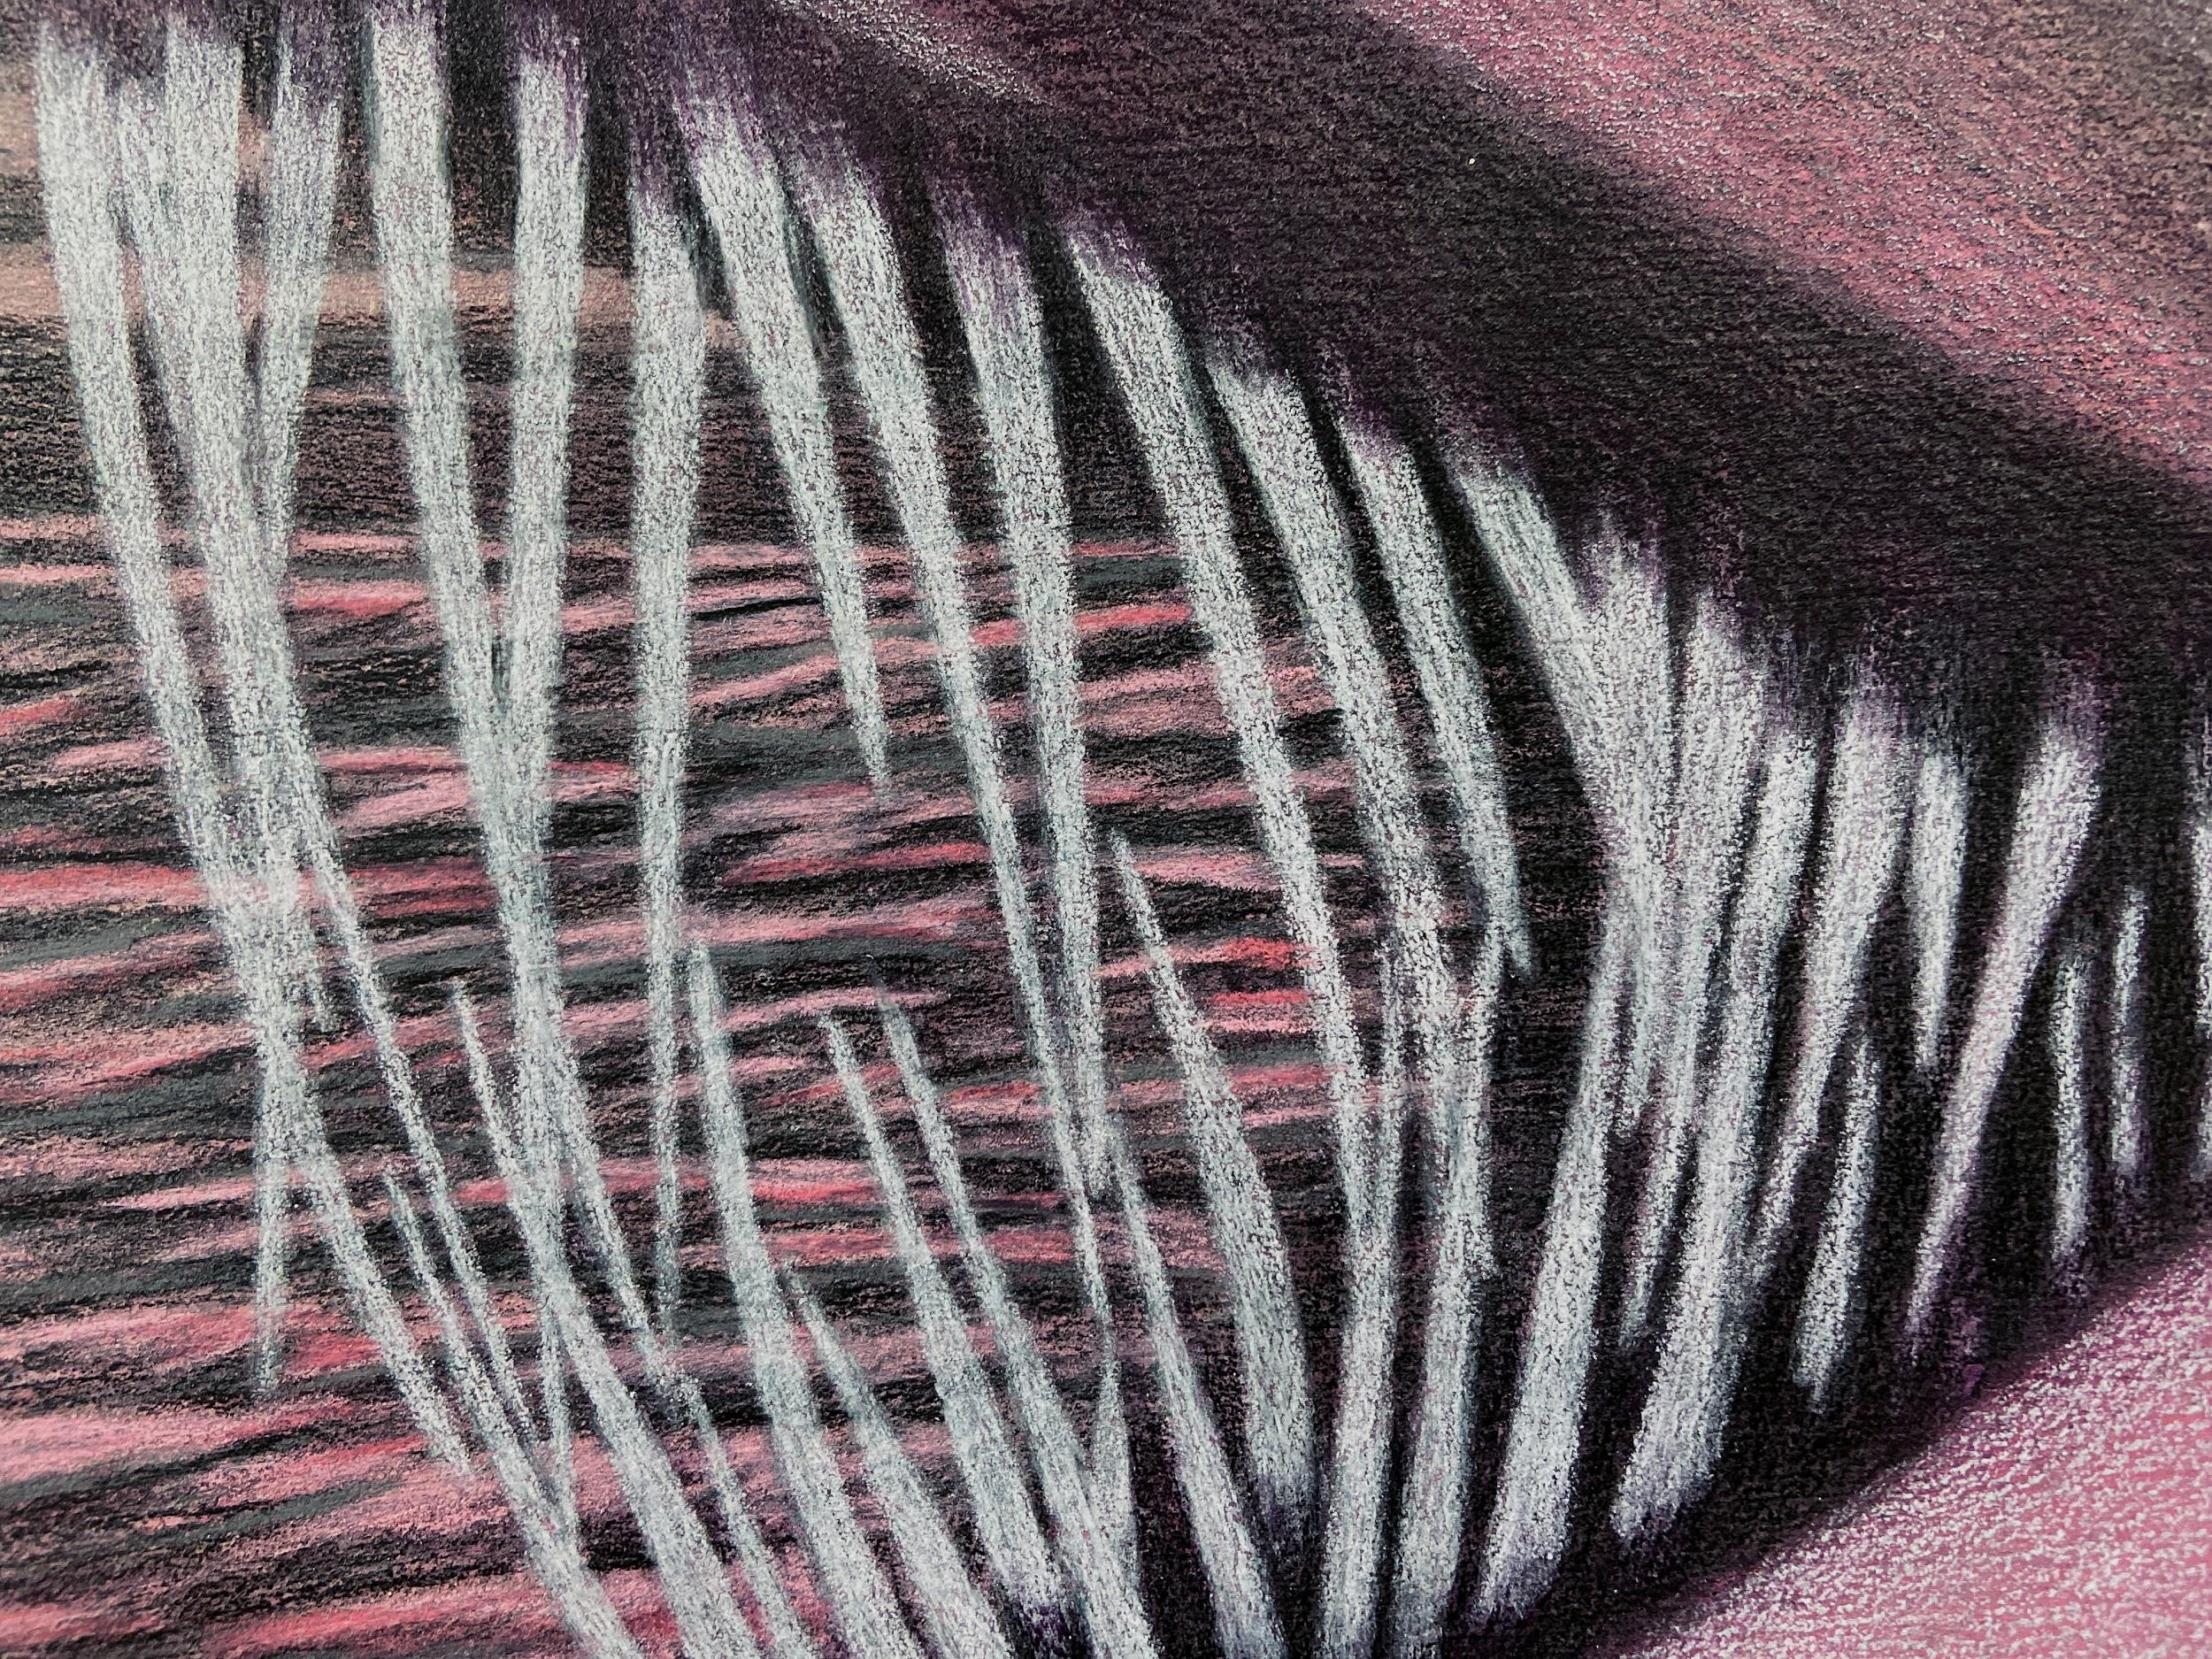

Tess Bilhartz’s solo exhibition What on Earth at Super Dutchess Gallery depicts an imagined mermaid sighting. Images of this sometimes monstrous, sometimes vulnerable figure flicker into focus and dissolve back into the water. The haze and heave of the ocean distort our view. Mermaids are the sirens who sing sailors to their deaths; they are red-haired Ariel in a clamshell bikini; they have also eaten humans alive with shark-like rows of long, pointy teeth. They have been known to evaporate into seafoam when their love for a human is unrequited. Glimpsed only in legends or by sailors on the verge of insanity and hallucination, mermaids are, in other words, the opposite of solid. How can a mermaid, with all her slippery shifting, be depicted?

Bilhartz uses stories that draw on the mythic, literary, cultural, and personal to generate the outline of imagery that she can then crop, distort, tear apart, or stitch back together. Her practice consists of a dialog between the structure of genre within narrative and the materiality of painting and drawing as an agent of dissonance and emotion. Bilhartz blends American landscape painting with fantasy; she harnesses drama, exaggeration, and a hint of horror. The artist utilizes the constructed focus of montage in the intentionally shaped sheets of watercolor paper to evoke singular moments which encourage the viewer to piece together a larger narrative. By literally distorting the format of the page, the events depicted become conspicuously altered. Figures direct the viewer’s attention towards what they wish to be seen, and thus also what they wish to remain hidden. The wall and floor bleed together as a single sensory experience, enhancing this effect.

Tess Bilhartz grew up in Dallas, Texas and lives and works in Brooklyn. She presented her first solo show, Purple Nights, at Arts and Leisure Gallery in 2016, followed by On A Good Night at 0-0 LA in 2017. She has participated in recent group exhibitions at Embajada, 0-0 LA, Orgy Park, The Willows, Arts and Leisure Gallery, Lesley Heller Workspace, The Spring Break Art Fair, and Bannerette. Residencies include the Skowhegan School of Painting and Sculpture in 2017, the DNA Summer Residency program in Provincetown, MA in 2015, and the Sharpe-Walentas Studio program in 2013-2014.

